DEEP ENTITY and EXPANDED Entity Implementation.

**Structure1:** SE11 -> Choose Data type->Structure ZTRUPEN_S_ODATA_MAT_BASIC.

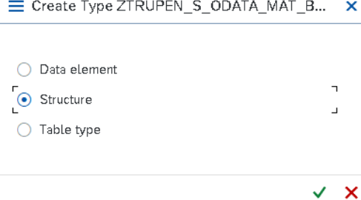\

Create the Structure with following fields.

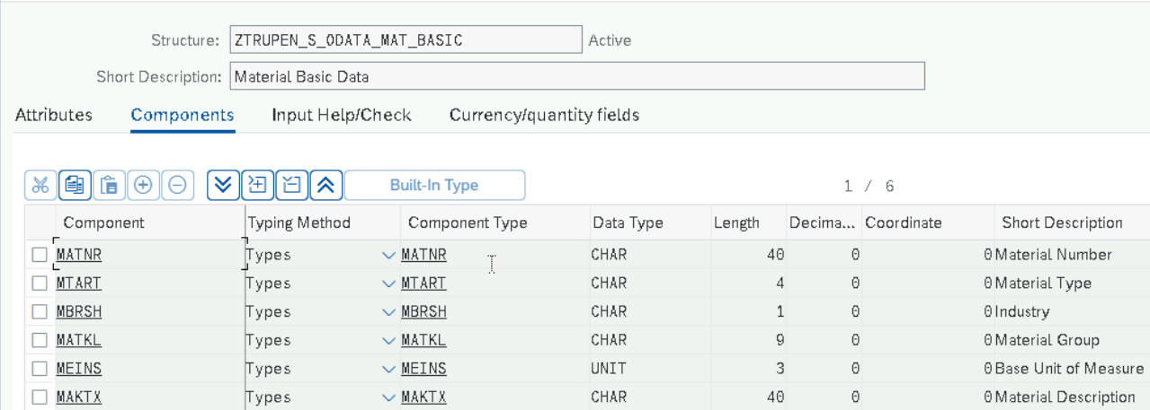

Save and activate the Structure.

**Structure2:** Create Structure for including the sales Data for the Material Master and provide the name and click on Create.

SE11 -> Choose Data type->Structure ZTRUPEN_S_ODATA_MAT_SALES.

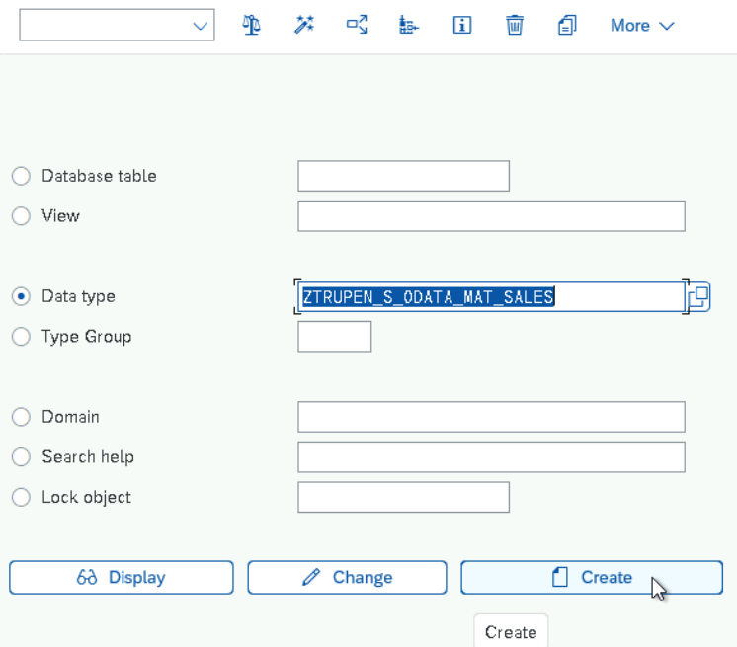

Choose the type as Structure and click on Enter.

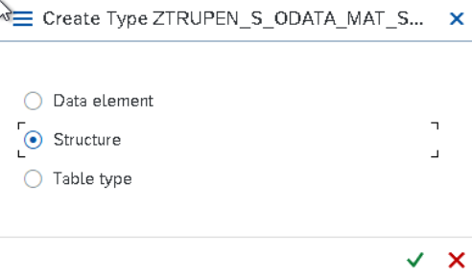

Provide the Short Description and add the field name in the Component and Data Element in the Component type.

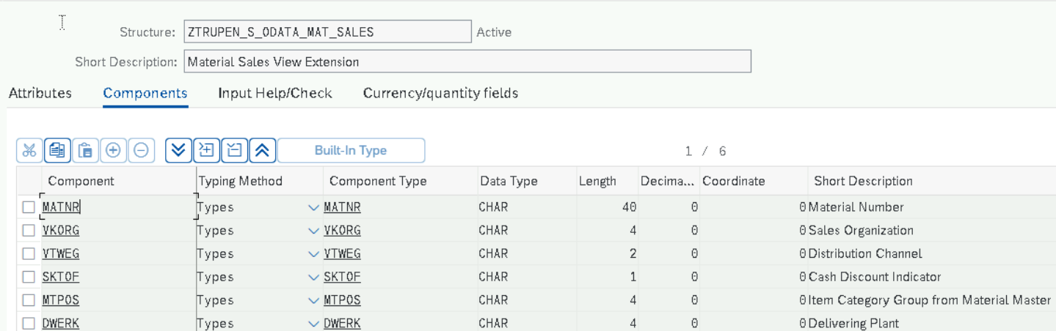

Save and Activate the structure now and the below Pop up will be shown to save the structure under the package. Enter the Package name and click on Save.

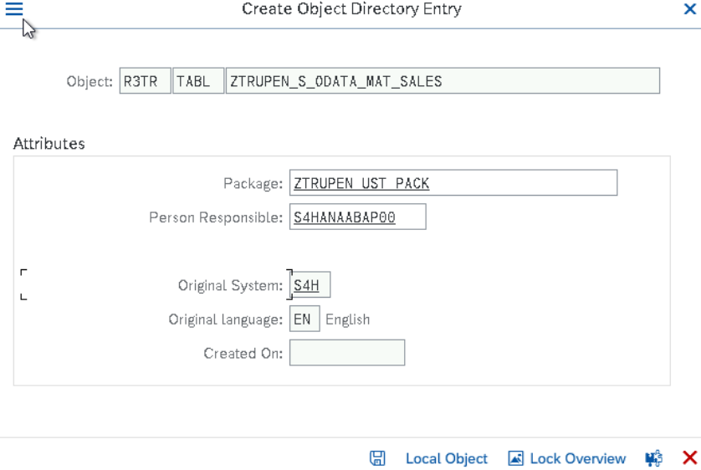

Provide the Transport number and click on Enter.

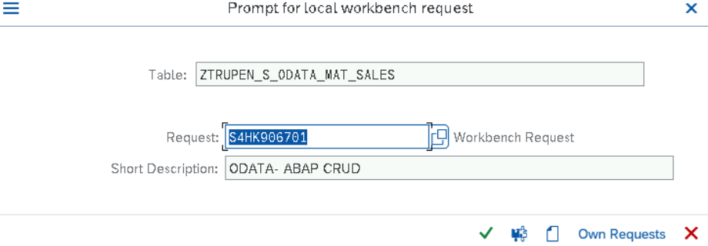

Create Table Type ZTRUPEN_TT_ODATA_MAT_SALES for structure ZTRUPEN_S_ODATA_MAT_SALES as

One material can have Multiple Sales View. Go to SE11->Choose Data Type->Give the Name->Click on Create Button.

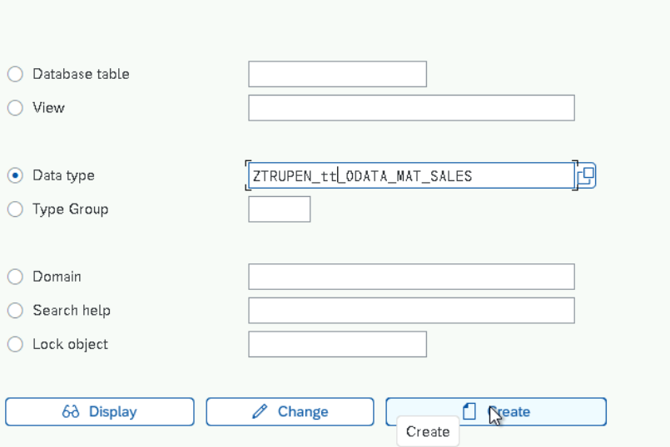

Choose Table Type and Click on ENter

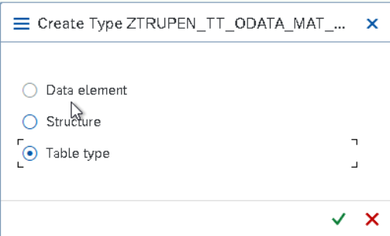

Provide the Description for Table Type and mention the structure name in the Line Type .

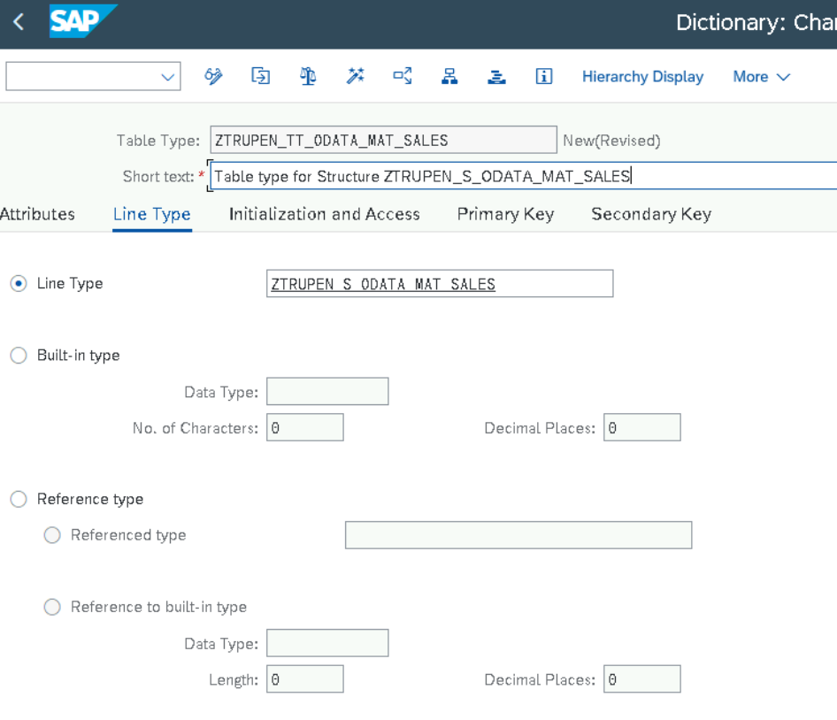

Now Save & Activate the Table Type. Provide the Package name and TR name during the Save.

**DEEP ENTITY STRUCTURE**

Create the Structure for the Deep Entity and by including the Structures created for the Material Basic and Material Sales data. Go to Tcode SE11 and choose Data type and provide the name as ZTRUPEN_S_ODATA_MATMAST

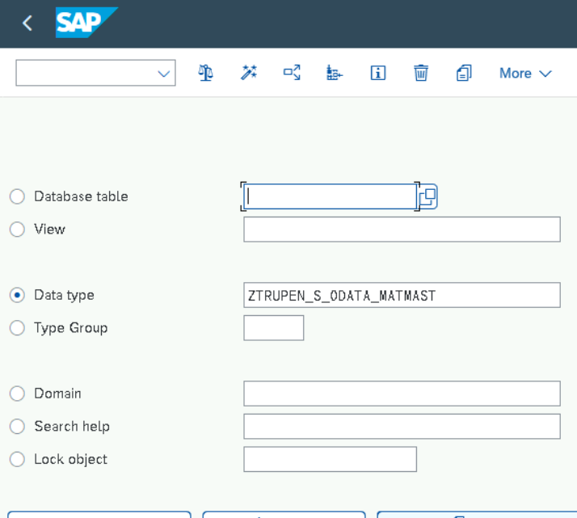

Choose the Type as Structure

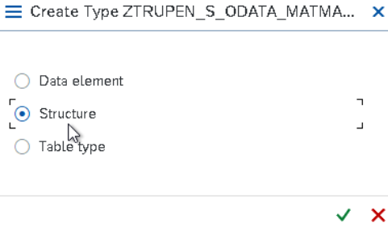

Use Include structure to include the fields from the structure already created in the system.

Click on Edit->include->Insert

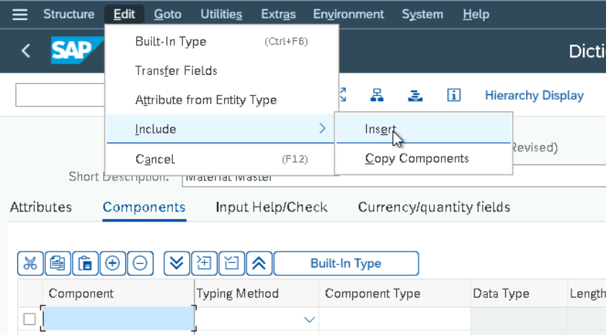

Mention the structure to be added and click on Enter.

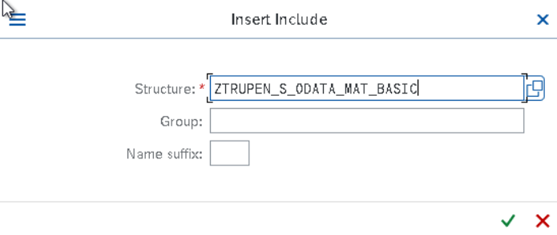

Add the table type created for the Sales structure to the component list after the Include structure.

The Table Type Component Name should be same as the Navigation property defined in the Odata Entities. By Default system proposes the Dependent Entity name or Dependent Entity table type name as Navigation Property name. (Refer Below for the Entity Navigation Name) Providing the Component name as MATSALES for the Table type.

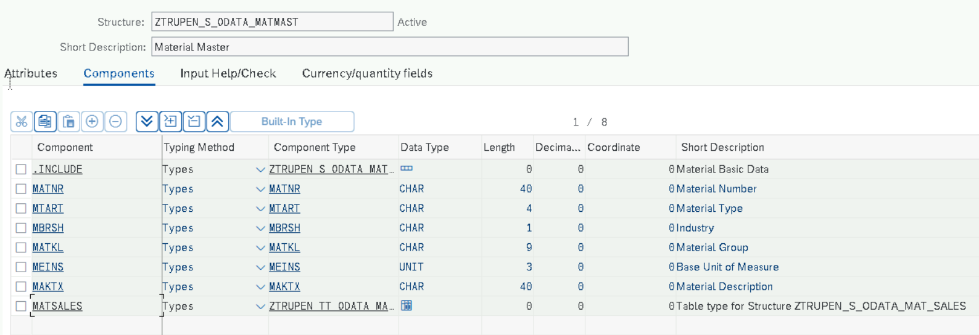

Now Save and Activate the Structure.

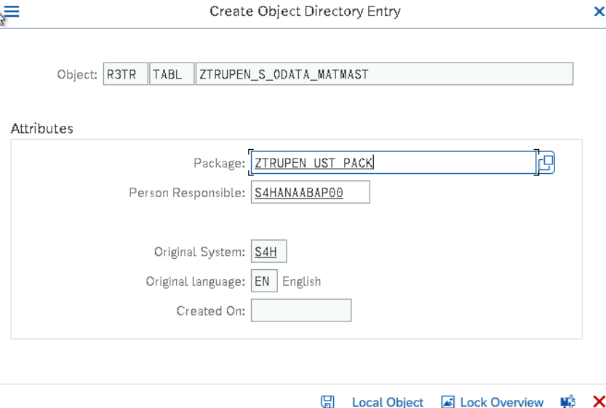

Click on save and provide the TR number.

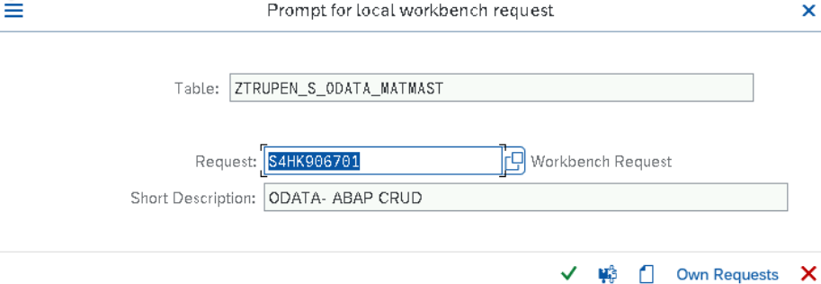

Now Click on Enter and Activate the Structure.

**GATEWAY SERVICE Builder – SEGW**

Copy the Existing ODATA project created for Material Master BASIC Data and Enhance it with the Additional Entity and create a new ODATA service to create the Material Master with Basic Data and Sales Data Together. Here we will explore the Need of Navigation and Associations as we have multiple entities in the ODATA for Sales and Basic data.

**GATEWAY SERVICE BUILDER**

Open SEGW Transaction and Click on Create Button for the Gateway Service Creation.

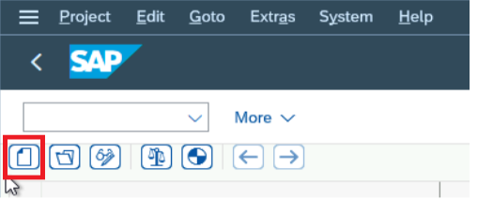

Now Provide the Project name, Description, Project type and Package for Service create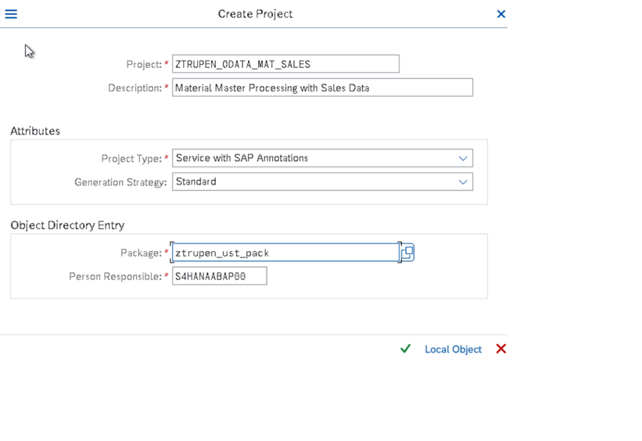

Click on Enter and the below screen will appear.

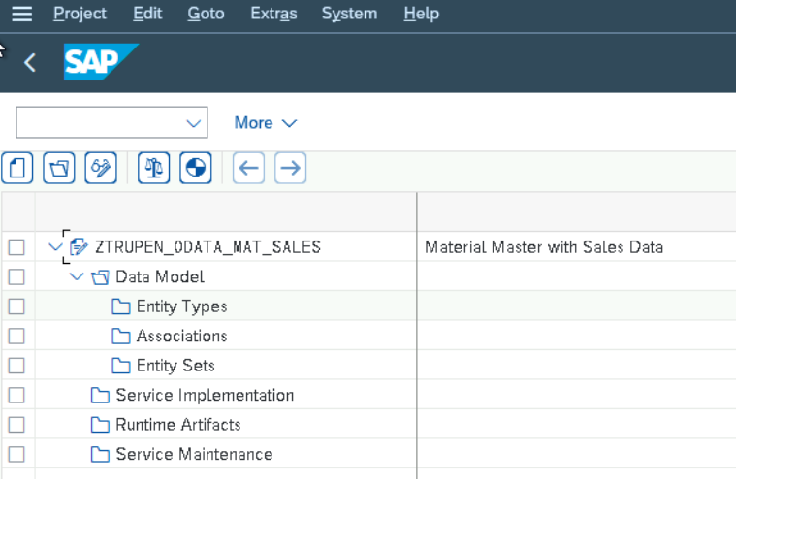

Now we could see that New project has been added and the Entity types ,Entity Sets can be added now.

Include the New Entity types in the Service by right clicking on the DataModel->Import->DDIC Structure.

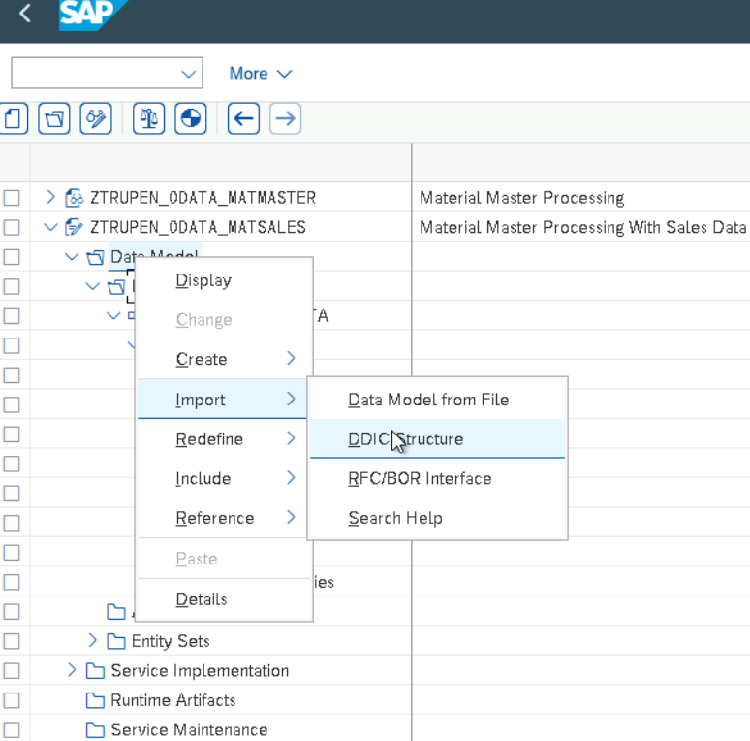

Now provide the Entity name and choose the structure and click on Next button.

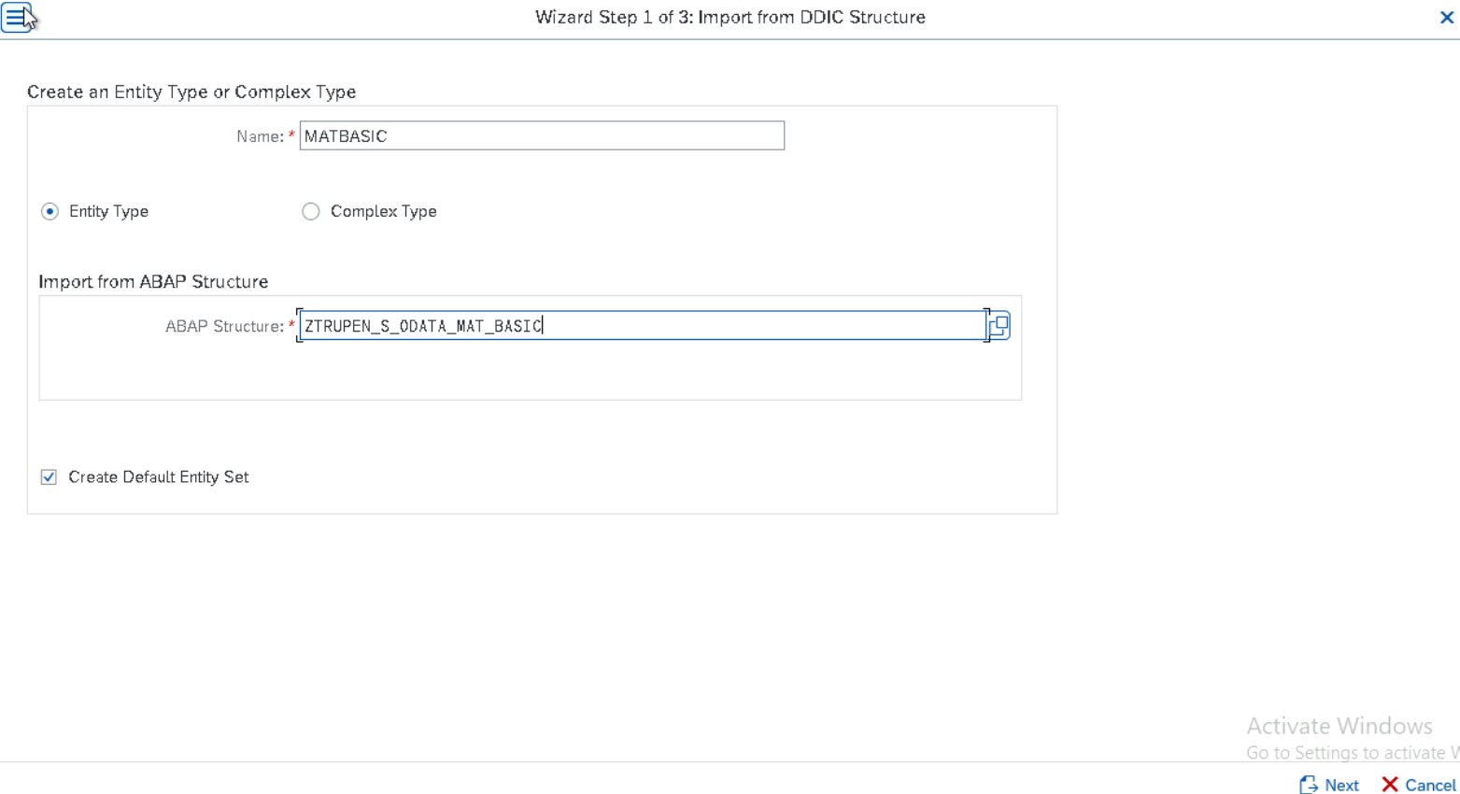

Select the Required fields for the Entity from the structure and click on Next Button.

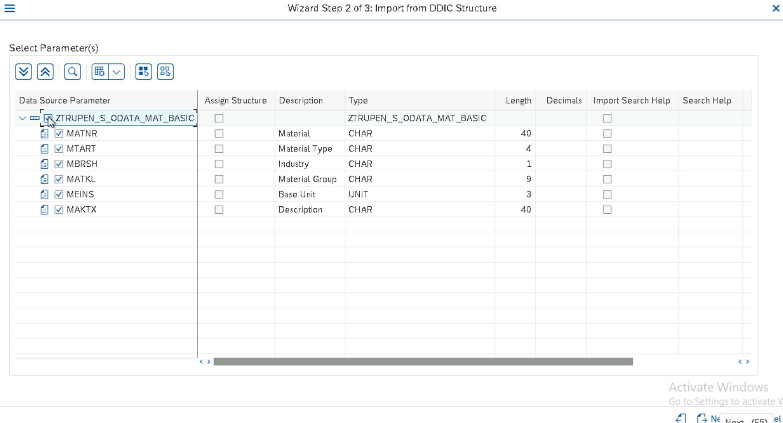

Choose the Key Field and click on Finish button.

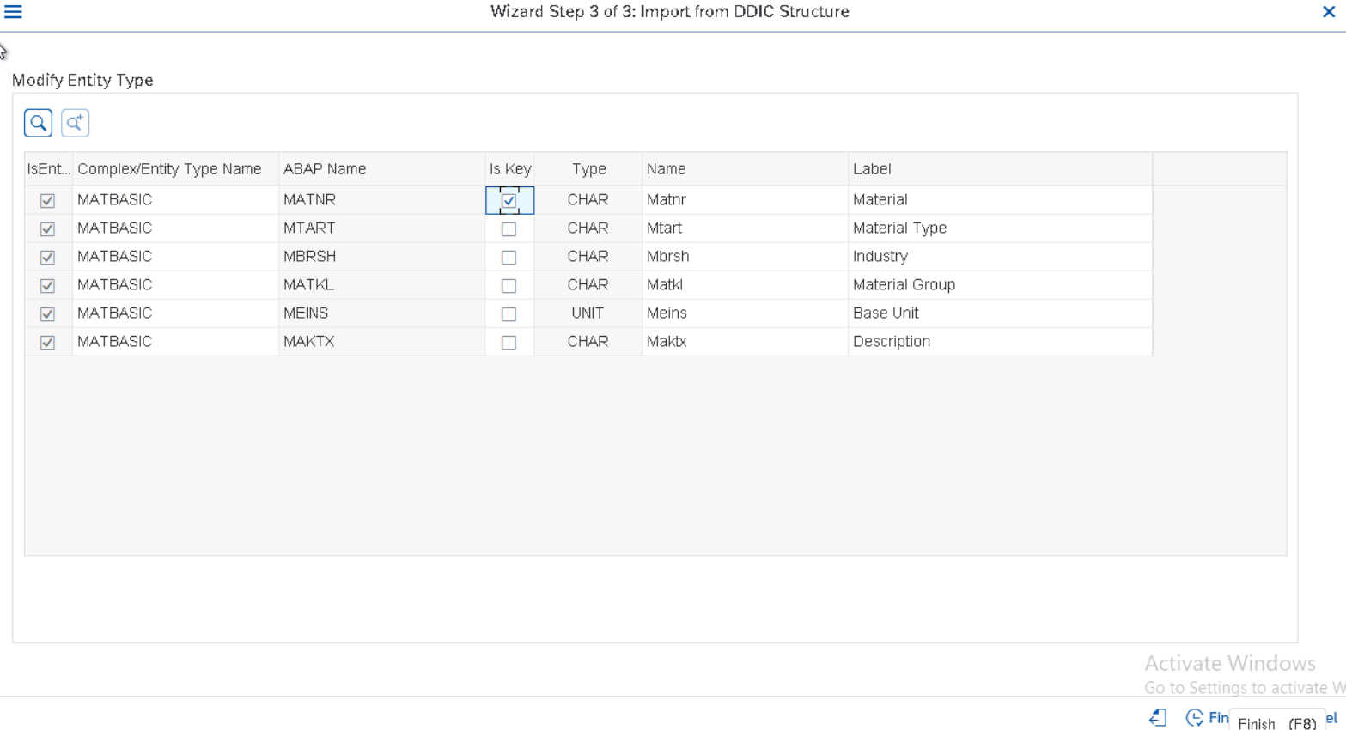

Include the second Entity types in the Service by right clicking on the Data Model->Import->DDIC Structure.



Now provide the Entity name and choose the structure and click on Next button.

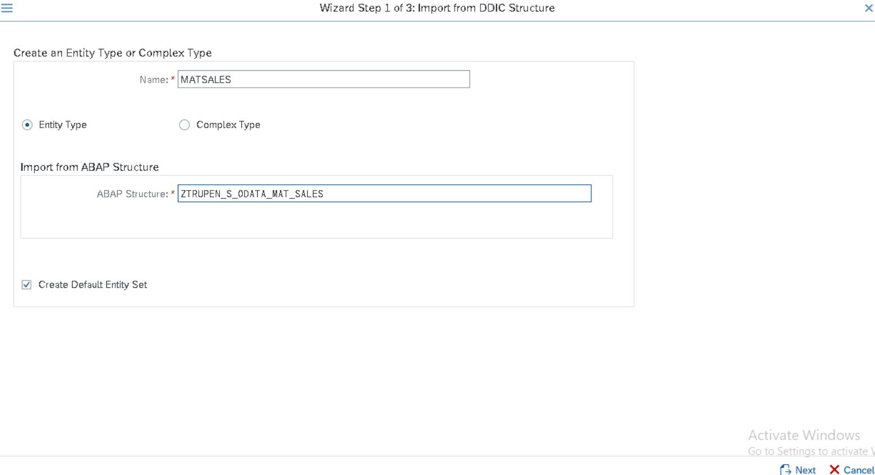

Now Select the Required fields to the entity from the structure fields and click on Next button to choose the Key fields for the Entity.

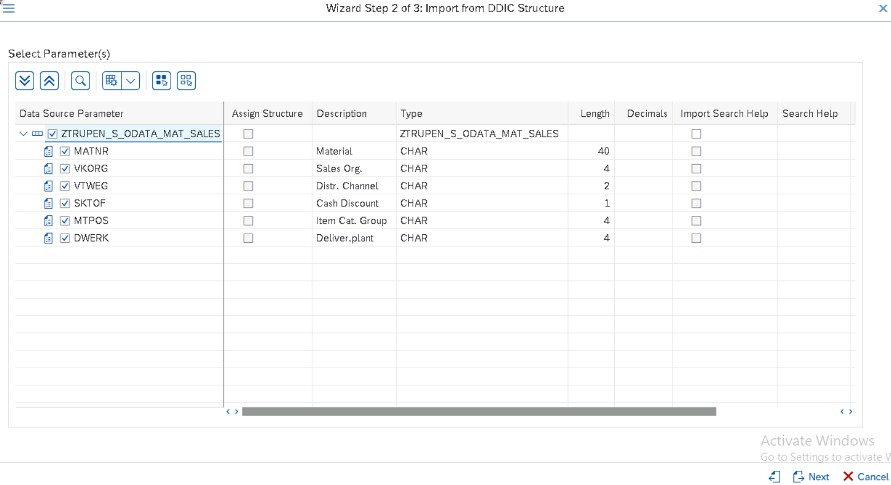

Now Choose the Key Fields for the Entity and click on Finish Button to add the Entity.

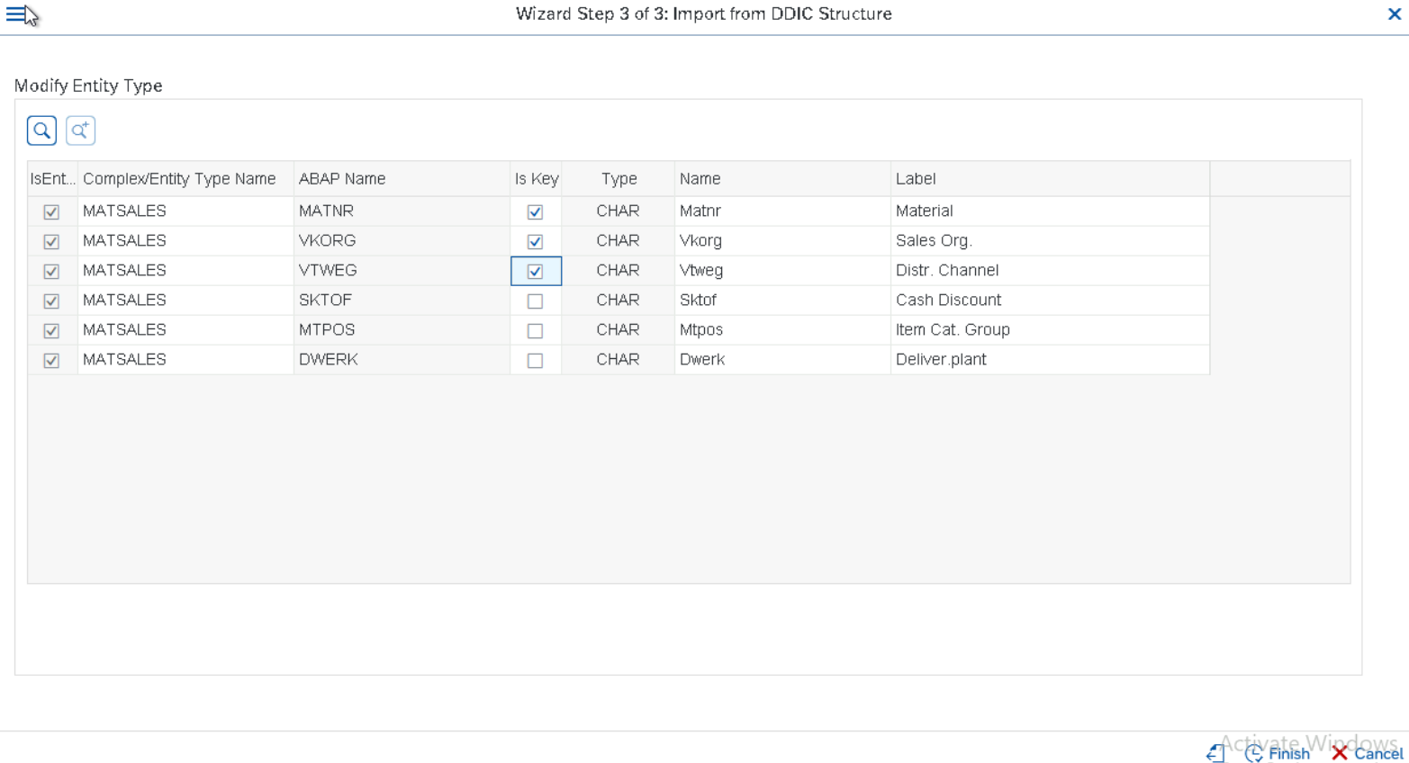

Now we could see that additional Entities are added to the Data Model.

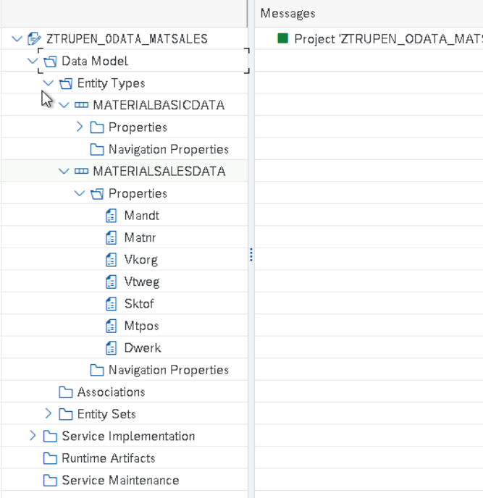

**Association and Navigation**

Association helps us to define the cardinality between the Entity types and can be defined between the Entities. Navigation is a property that helps to retrieve the Dependent Entry Data between multiple entities.

Here the Association must be defined between the MATERIALBASICDATA and MATERIALSALESDATA and the Corresponding Navigation must be defined, and the Fields should be mapped. Right click on Association and click on Create Button to define the Association between the Entities.

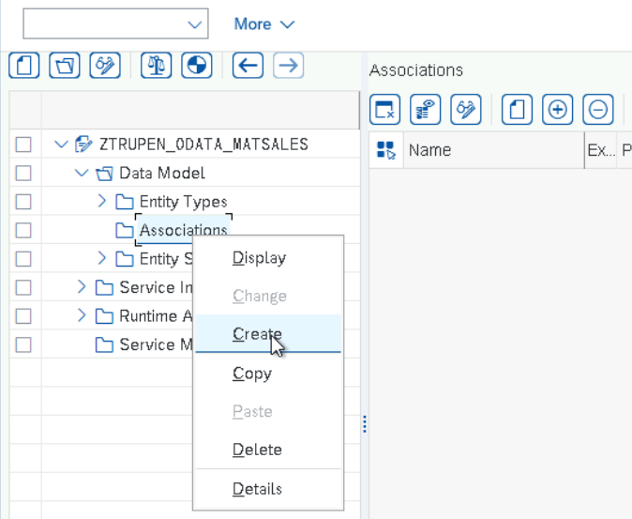

We need to provide Association Name as MAT_TO_SALES and choose the Principal Entity type and Dependent Entity Type name, Define the Cardinality between the Principal Entity and the Dependent Entity. Check the Create Related Navigation property for both the Principal Entity and the Dependent Entity to create the Navigation Automatically between the Entity types. Click on next Button to proceed with the Referential Constraint creation.

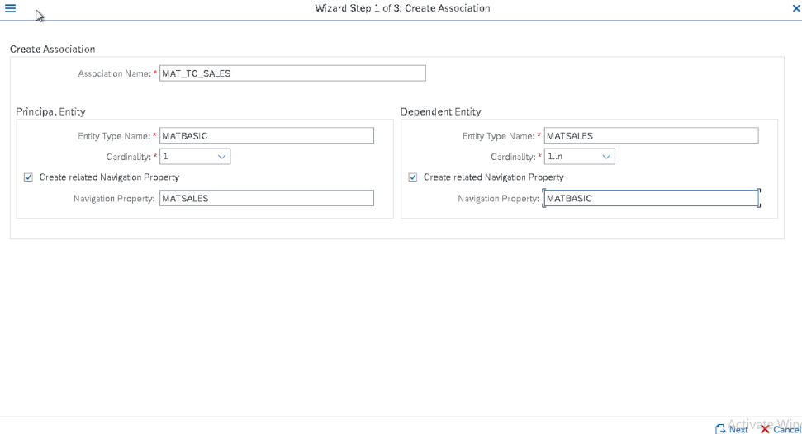

Define the Referential Constraint for the Entity type where the Key field of the Principal Entity has to be matched with the Dependent Entries. Map the field name from both the Entity and Click on Next Button.

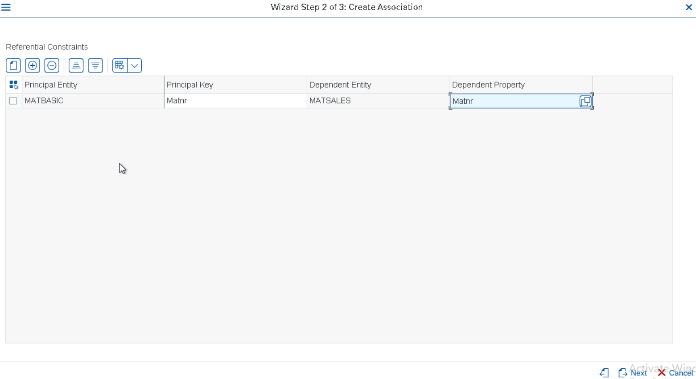

The system automatically proposes the Association Set name for the corresponding Principal Entity Set name and Dependent Entity set Name.

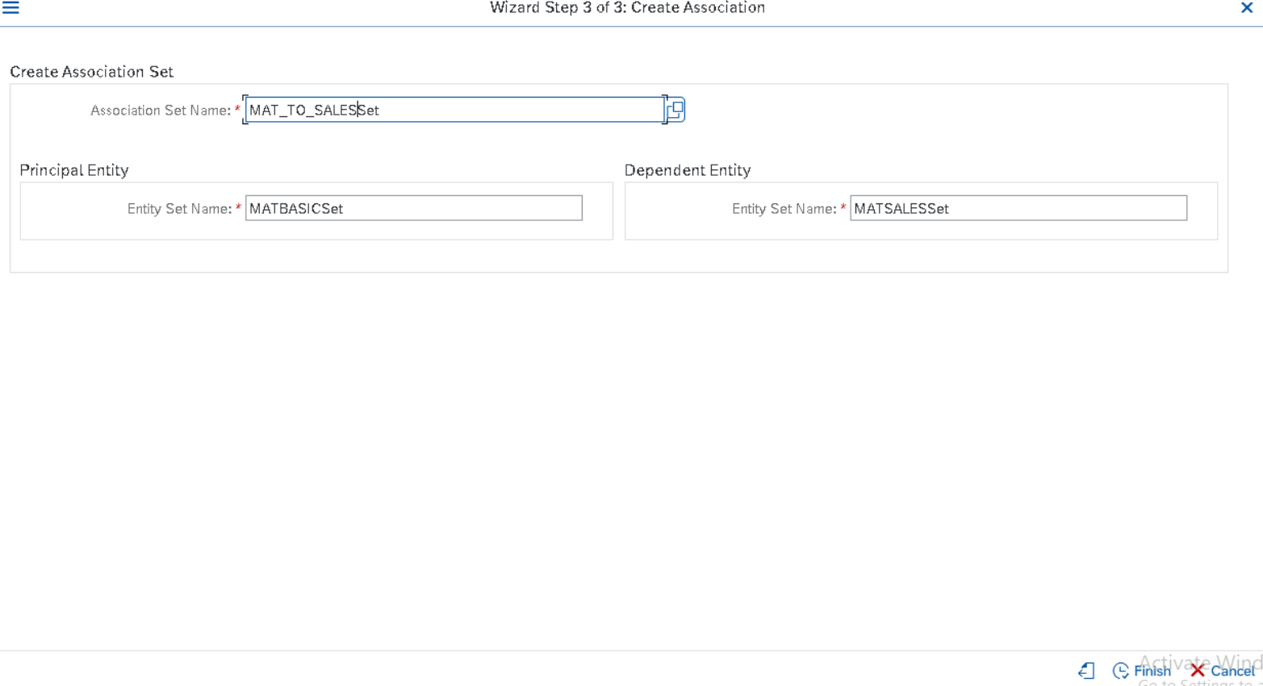

Generate the Runtime Objects by clicking on the Generate Runtime Objects icon.

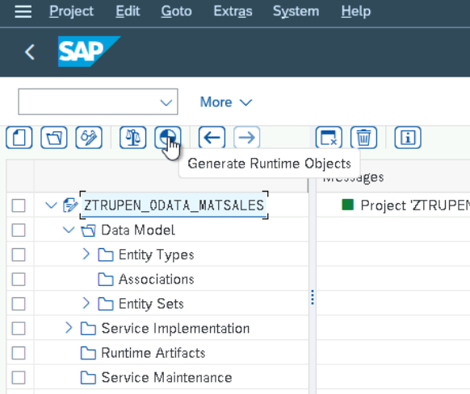

Provide the TR Number and Click on Enter Button.

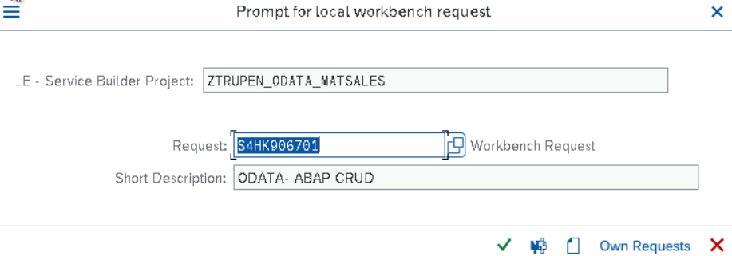

Now System proposes the Class name for Data Provider class, Model provider class, Technical model name and technical Service name and modify the name according to the preferred Naming Convention if required and Click on Enter button to create the Class .model and Service.

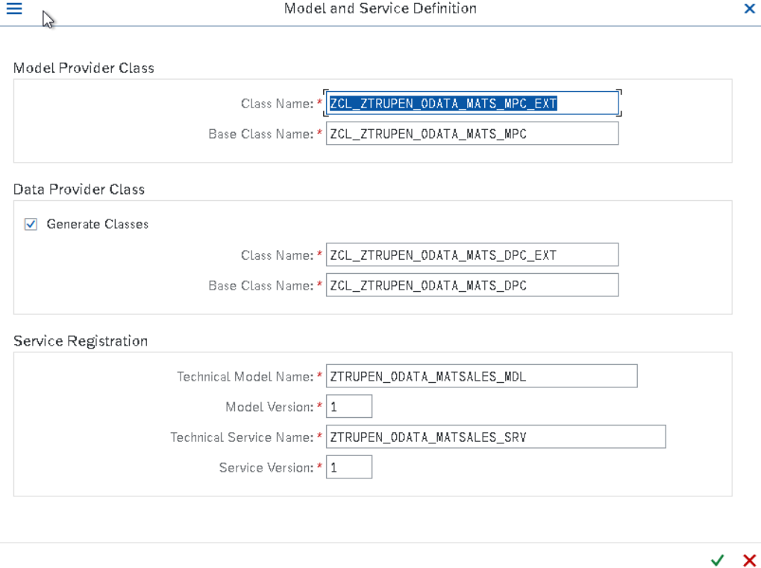

Provide the Package Name and click on enter.

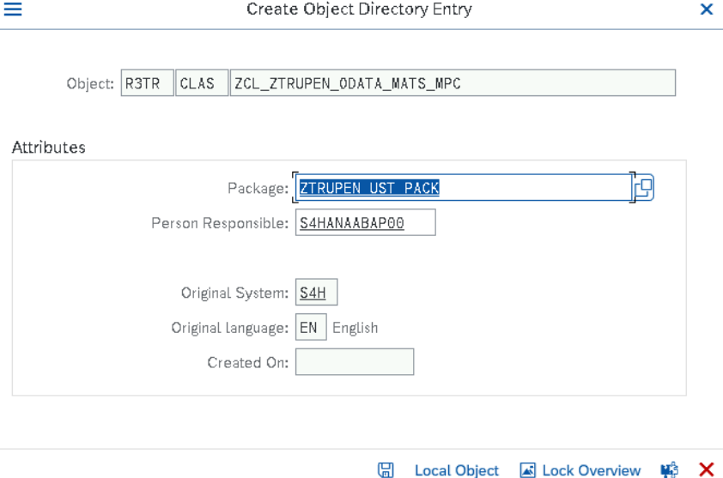

Provide the Transport number in the Request and Click on Enter.

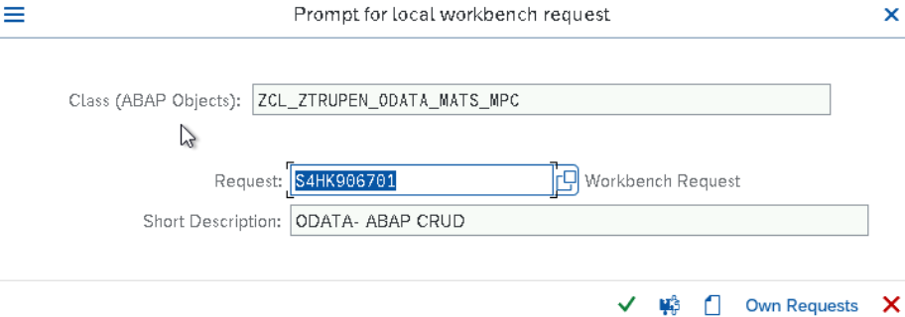

Runtime Objects are created now and the below screen shows that the Data provider extension and Model provider Class extension to assign the structure for Deep Entity and process the data from the Deep Entity .

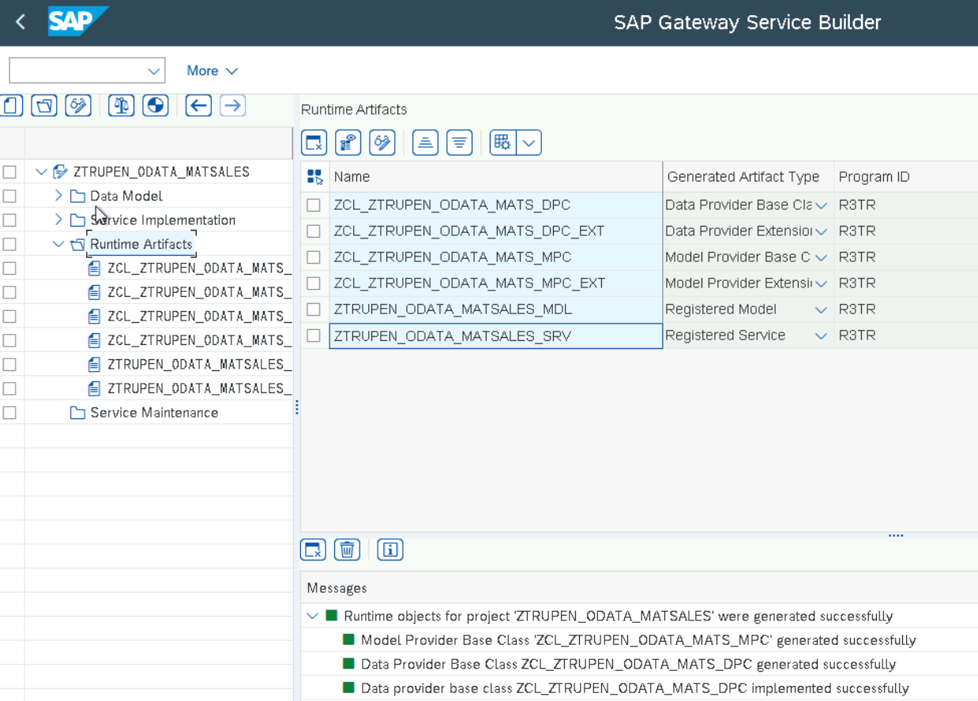

Implement the Run time Objects by double clicking on the ZCL_ZTRUPEN_ODATA_MATS_MPC_EXT and redefine the Method Define to assign the structure ZTRUPEN_S_ODATA_MATMAST for the Entity and Redefine the Method /IWBEP/IF_MGW_APPL_SRV_RUNTIME~CREATE_DEEP_ENTITY in the class ZCL_ZTRUPEN_ODATA_MATS_DPC_EXT to handle the Data.

Redefining Model provider Class

Double Click on ZCL_ZTRUPEN_ODATA_MATS_MPC_EXT to redefine the method Define.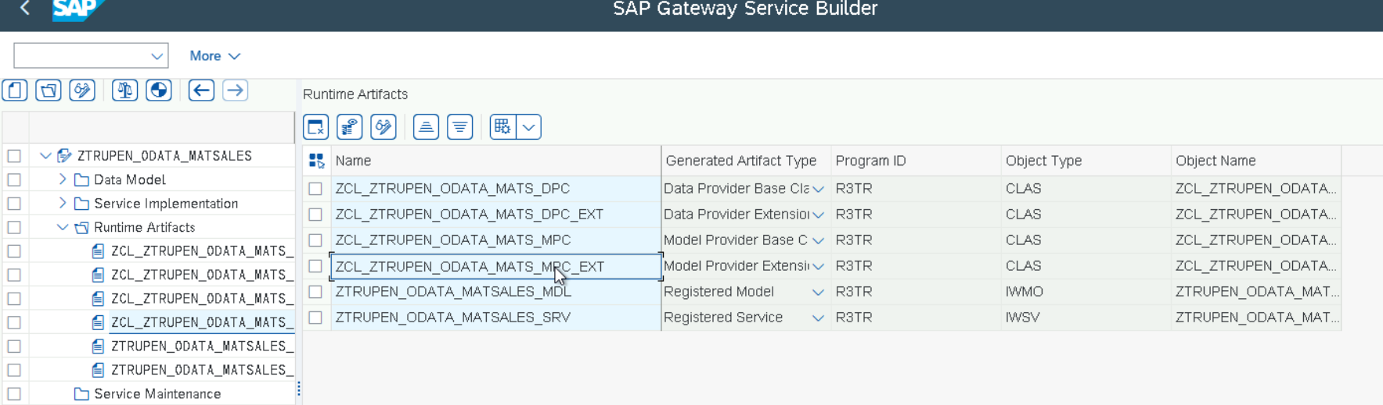

We can navigate to the Class through the gateway Service Builder SEGW Transaction or SE24 Transaction. Now We could See the Method Define without any Redefinition.

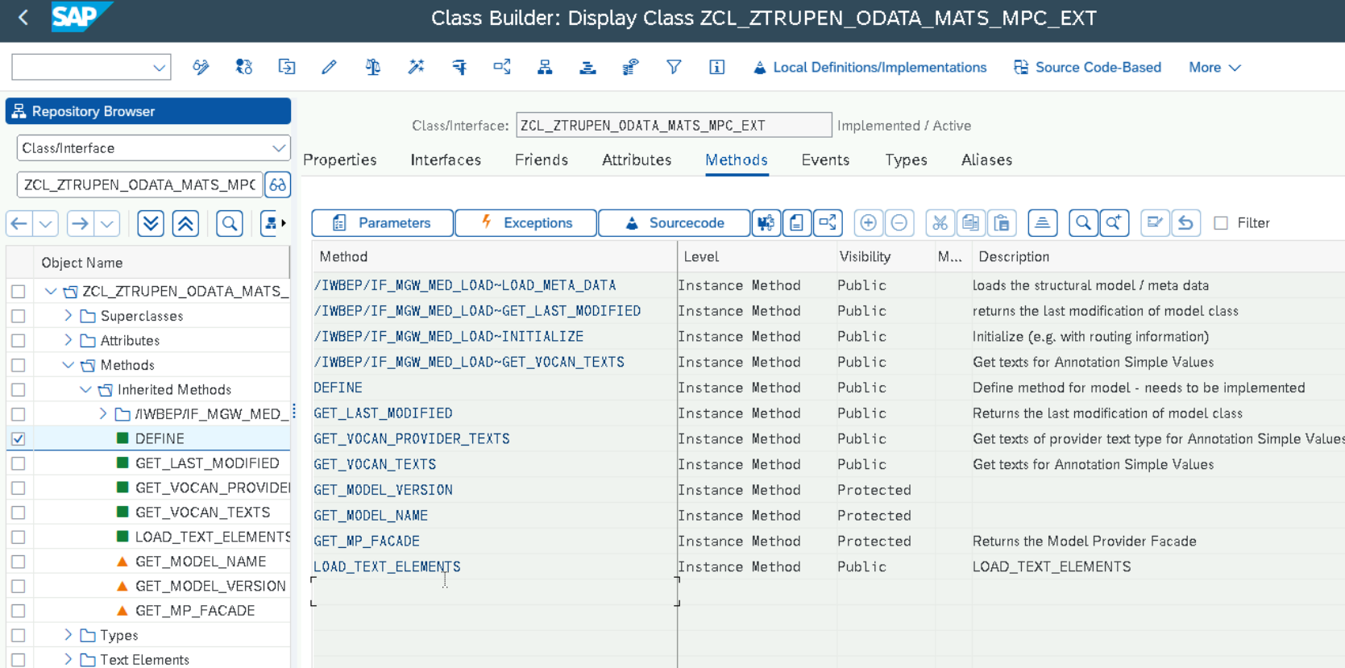

Right Click on the Define Method -> click on Redefine to implement the Logic.

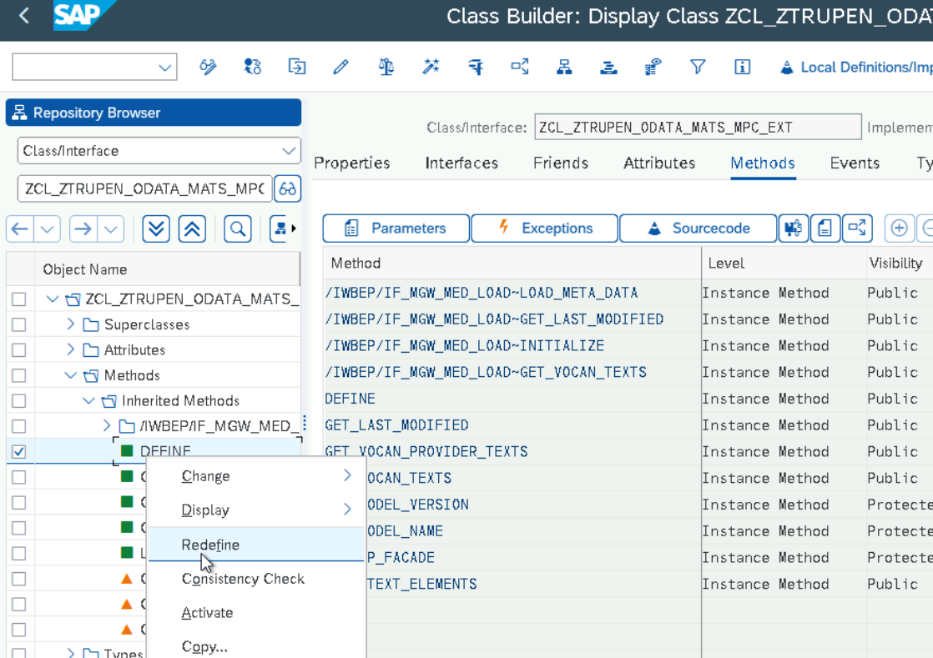

The Method is Re defined and the logic is written to create the Deep Entity with name MATBSAIC and the entity Structure as ‘ZTRUPEN_S_ODATA_MATMAST’.

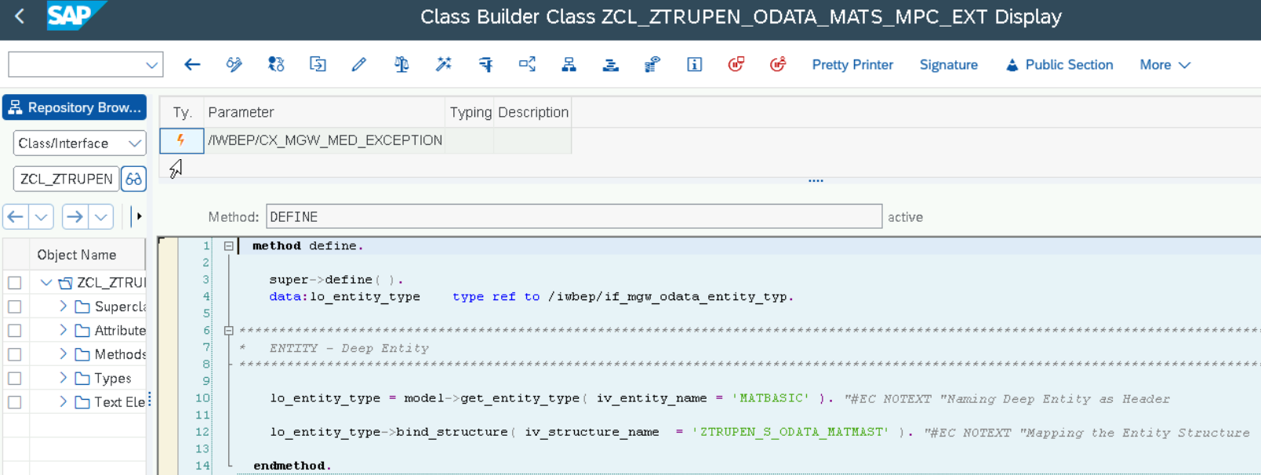

**Source Code:**

  method define.  
    super->define( ).  
    data:lo_entity_type    type ref to /iwbep/if_mgw_odata_entity_typ.  
***********************************************************************************************************************************  
*   ENTITY - Deep Entity  
***********************************************************************************************************************************  
    lo_entity_type = model->get_entity_type( iv_entity_name = 'MATBASIC' ). "#EC NOTEXT "Naming Deep Entity as Header  
    lo_entity_type->bind_structure( iv_structure_name  = 'ZTRUPEN_S_ODATA_MATMAST' ). "#EC NOTEXT "Mapping the Entity Structure  
  endmethod.

Now Go Back to ZCL_ZTRUPEN_ODATA_MATS_DPC_EXT class to redefine the method /IWBEP/IF_MGW_APPL_SRV_RUNTIME~CREATE_DEEP_ENTITY and /IWBEP/IF_MGW_APPL_SRV_RUNTIME~GET_EXPANDED_ENTITY.

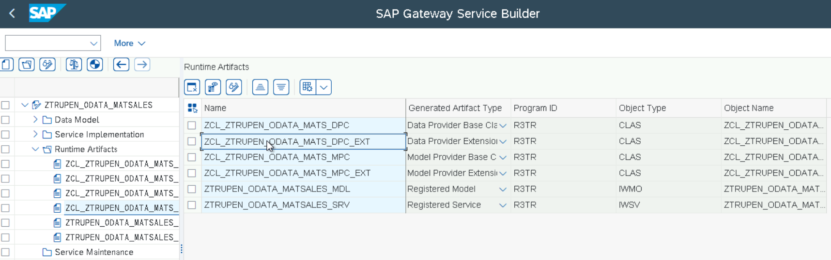

Now the Class ZCL_ZTRUPEN_ODATA_MATS_DPC_EXT is opened. the Method CREATE_DEEP_ENTITY can be redefined.

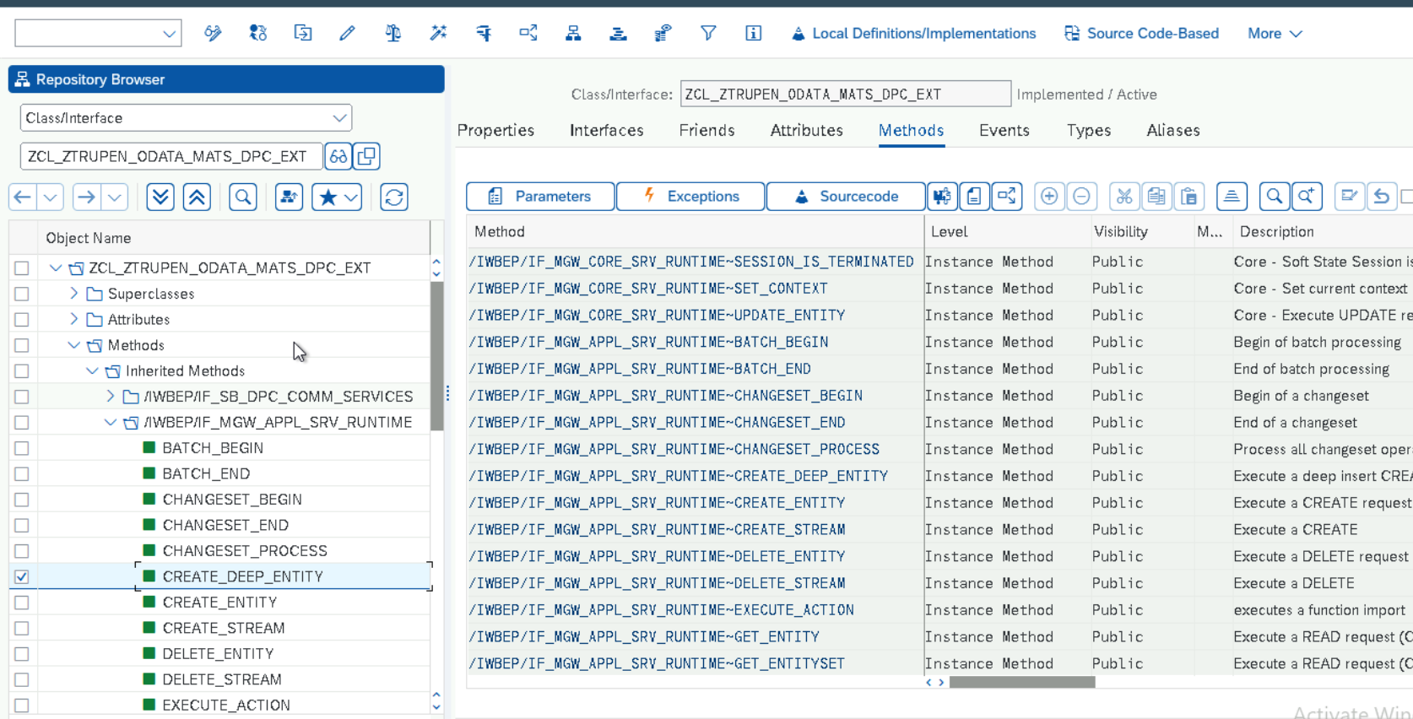

Right Click on the Method CREATE_DEEP_ENTITY -> Click on REDEFINE method.

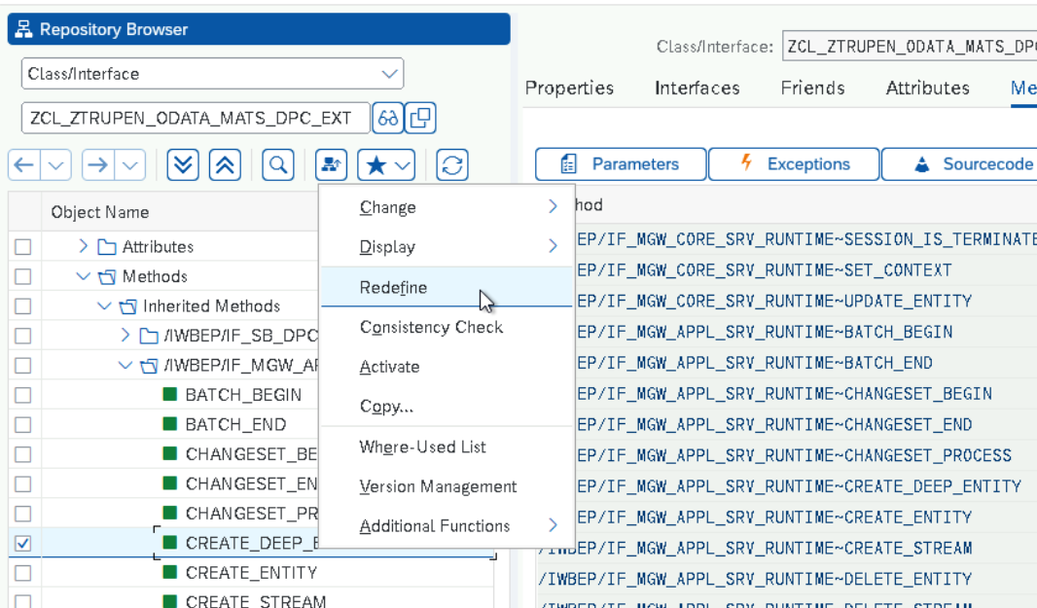

Now the Method is redefined with the Logic to create the material with Basic data and Sales Data.

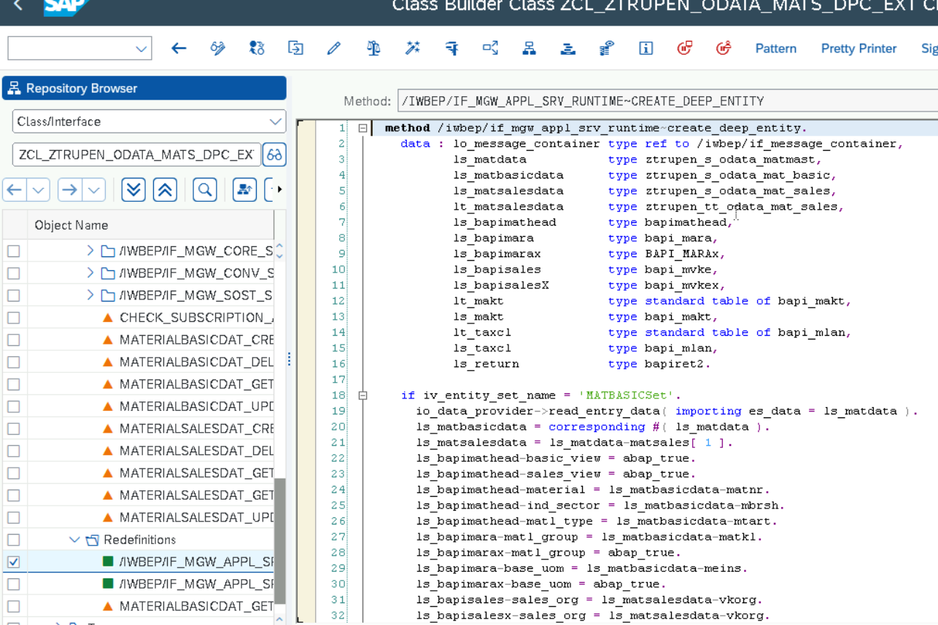

**Source Code:**

  method /iwbep/if_mgw_appl_srv_runtime~create_deep_entity.  
    data : lo_message_container type ref to /iwbep/if_message_container,  
           ls_matdata           type ztrupen_s_odata_matmast,  
           ls_matbasicdata      type ztrupen_s_odata_mat_basic,  
           ls_matsalesdata      type ztrupen_s_odata_mat_sales,  
           lt_matsalesdata      type ztrupen_tt_odata_mat_sales,  
           ls_bapimathead       type bapimathead,  
           ls_bapimara          type bapi_mara,  
           ls_bapimarax         type BAPI_MARAx,  
           ls_bapisales         type bapi_mvke,  
           ls_bapisalesX        type bapi_mvkex,  
           lt_makt              type standard table of bapi_makt,  
           ls_makt              type bapi_makt,  
           lt_taxcl             type standard table of bapi_mlan,  
           ls_taxcl             type bapi_mlan,  
           ls_return            type bapiret2.  
  
    if iv_entity_set_name = 'MATBASICSet'.  
      io_data_provider->read_entry_data( importing es_data = ls_matdata ).  
      ls_matbasicdata = corresponding #( ls_matdata ).  
      ls_matsalesdata = ls_matdata-matsales[ 1 ].  
      ls_bapimathead-basic_view = abap_true.  
      ls_bapimathead-sales_view = abap_true.  
      ls_bapimathead-material = ls_matbasicdata-matnr.  
      ls_bapimathead-ind_sector = ls_matbasicdata-mbrsh.  
      ls_bapimathead-matl_type = ls_matbasicdata-mtart.  
      ls_bapimara-matl_group = ls_matbasicdata-matkl.  
      ls_bapimarax-matl_group = abap_true.  
      ls_bapimara-base_uom = ls_matbasicdata-meins.  
      ls_bapimarax-base_uom = abap_true.  
      ls_bapisales-sales_org = ls_matsalesdata-vkorg.  
      ls_bapisalesx-sales_org = ls_matsalesdata-vkorg.  
      ls_bapisales-distr_chan = ls_matsalesdata-vtweg.  
      ls_bapisalesx-distr_chan = ls_matsalesdata-vtweg.  
      ls_bapisales-cash_disc = ls_matsalesdata-sktof.  
      ls_bapisalesx-cash_disc = abap_true.  
      ls_bapisales-delyg_plnt = ls_matsalesdata-dwerk.  
      ls_bapisalesx-delyg_plnt = abap_true.  
      ls_bapisales-item_cat = ls_matsalesdata-mtpos.  
      ls_bapisalesx-item_cat = abap_true.  
  
      ls_makt-langu = 'E'.  
      ls_makt-matl_desc = ls_matbasicdata-maktx.  
      append ls_makt to lt_makt.  
  
      ls_taxcl-depcountry = 'DE'.  
      ls_taxcl-taxclass_1 = '1'.  
      ls_taxcl-tax_type_1 =  'TTX1'.  
      ls_taxcl-depcountry_iso = 'DE'.  
      append ls_taxcl to lt_taxcl.  
      ls_taxcl-depcountry = 'IN'.  
      ls_taxcl-depcountry_iso = 'IN'.  
      ls_taxcl-tax_type_1 =  'JTX1'.  
      append ls_taxcl to lt_taxcl.  
      ls_taxcl-tax_type_1 =  'JTX2'.  
      append ls_taxcl to lt_taxcl.  
      ls_taxcl-tax_type_1 =  'JTX3'.  
      append ls_taxcl to lt_taxcl.  
      ls_taxcl-tax_type_1 =  'JTX4'.  
      append ls_taxcl to lt_taxcl.  
      ls_taxcl-depcountry = 'US'.  
      ls_taxcl-depcountry_iso = 'US'.  
      ls_taxcl-tax_type_1 =  'UTXJ'.  
      append ls_taxcl to lt_taxcl.  
  
      lo_message_container = me->mo_context->get_message_container( ).  
  
      call function 'BAPI_MATERIAL_SAVEDATA'  
        exporting  
          headdata            = ls_bapimathead  
          clientdata          = ls_bapimara  
          clientdatax         = ls_bapimarax  
          salesdata           = ls_bapisales  
          salesdatax          = ls_bapisalesx  
        importing  
          return              = ls_return  
        tables  
          materialdescription = lt_makt  
          taxclassifications  = lt_taxcl.  
      if ls_return-type ne 'E' and "Error  
       ls_return-type ne 'A' and "Abend  
      ls_return-type ne 'X' . "System Error  
        call function 'BAPI_TRANSACTION_COMMIT'  
          exporting  
            wait   = abap_true  
          importing  
            return = ls_return.  
  
        "only to display message text.  
  
        call method lo_message_container->add_message_text_only  
          exporting  
            iv_msg_type               = 'S'  
            iv_msg_text               = 'Material Created and extended with sales view Successfully'  
            iv_add_to_response_header = abap_true.  
  
  
        copy_data_to_ref( exporting is_data = ls_matdata changing cr_data = er_deep_entity ).  
      else.  
  
        call method lo_message_container->add_message_text_only  
          exporting  
            iv_msg_type               = 'E'  
            iv_msg_text               = 'Material is not created or extended to sales view'  
            iv_add_to_response_header = abap_true.  
  
      endif.  
    endif.  
  endmethod.

**GET_EXPANDED_ENTITY**

Similarly Redefine the method GET_EXPANDED_ENTITY Right click on the method and click on Redefine.

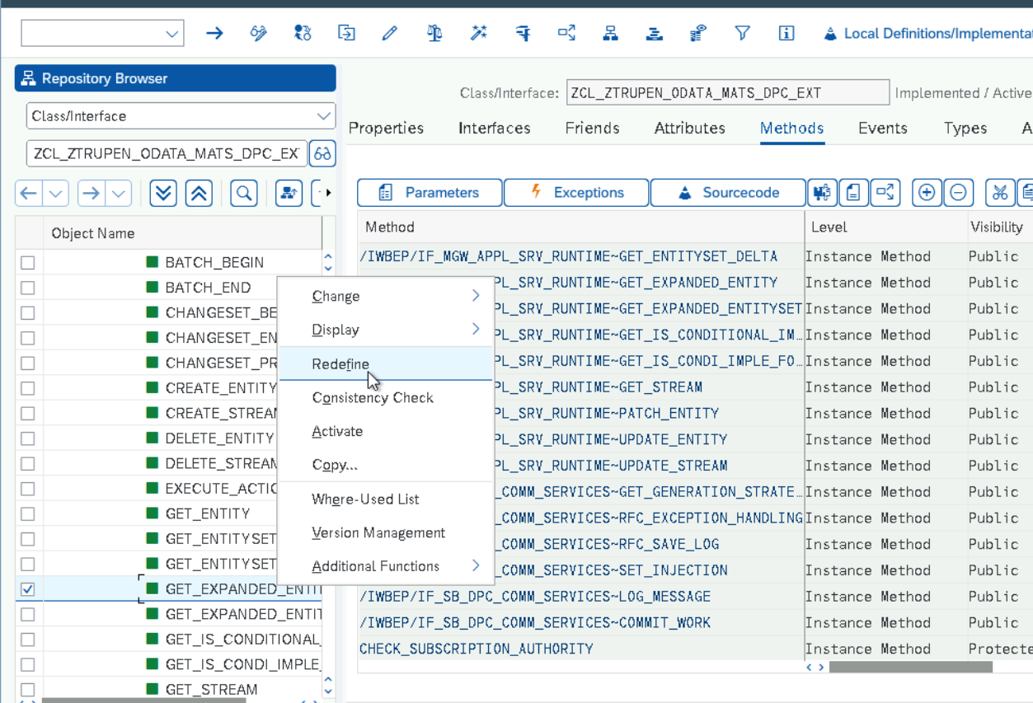

Now the Method is re defined and the logic is implemented for retrieving the Material Basic Data and Sales Data.

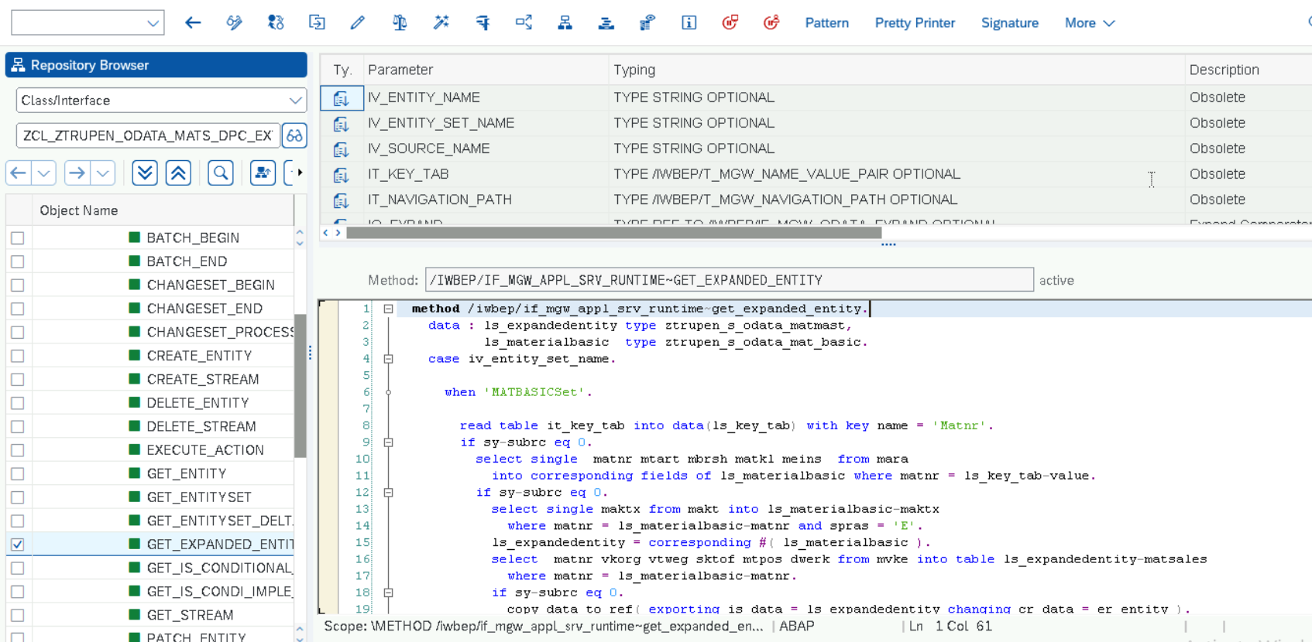

**Source Code**

  method /iwbep/if_mgw_appl_srv_runtime~get_expanded_entity.  
    data : ls_expandedentity type ztrupen_s_odata_matmast,  
           ls_materialbasic  type ztrupen_s_odata_mat_basic.  
    case iv_entity_set_name.  
  
      when 'MATBASICSet'.  
  
        read table it_key_tab into data(ls_key_tab) with key name = 'Matnr'.  
        if sy-subrc eq 0.  
          select single  matnr mtart mbrsh matkl meins  from mara  
            into corresponding fields of ls_materialbasic where matnr = ls_key_tab-value.  
          if sy-subrc eq 0.  
            select single maktx from makt into ls_materialbasic-maktx  
              where matnr = ls_materialbasic-matnr and spras = 'E'.  
            ls_expandedentity = corresponding #( ls_materialbasic ).  
            select  matnr vkorg vtweg sktof mtpos dwerk from mvke into table ls_expandedentity-matsales  
              where matnr = ls_materialbasic-matnr.  
            if sy-subrc eq 0.  
              copy_data_to_ref( exporting is_data = ls_expandedentity changing cr_data = er_entity ).  
            endif.  
          endif.  
          append 'MATSALES' to et_expanded_tech_clauses.  
        endif.  
      when others.  
    endcase.  
  endmethod.

**Service Registration**

Go to Transaction /IWFND/MAINT_SERVICE -> Click on Add Service.

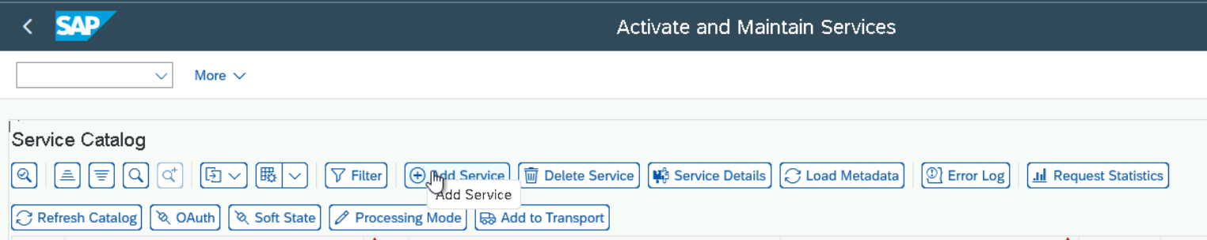

Enter the System Alias as LOCAL and Technical Service Name as ZTRUPEN_ODATA_MATSALES_SRV and click on Enter

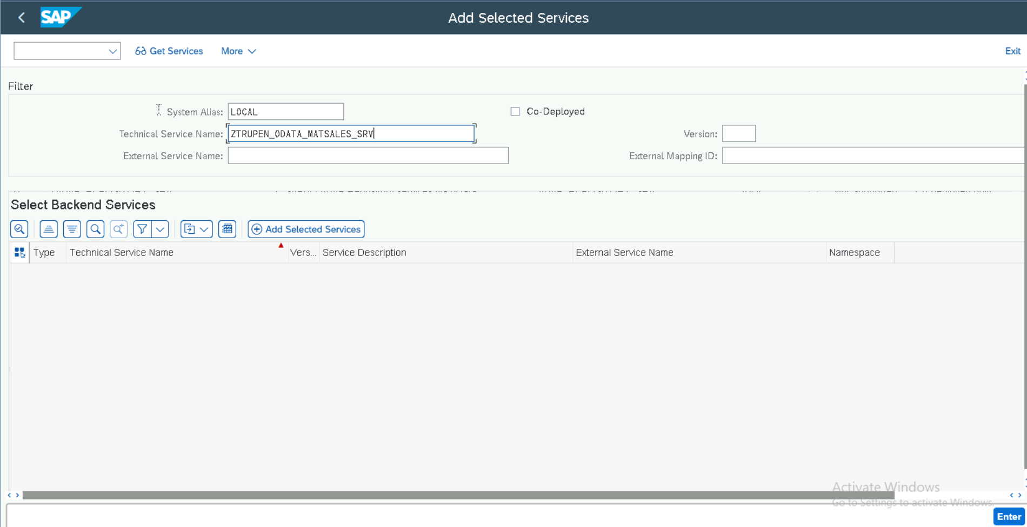

Now Click on Add Selected Services to Register the service in the system.

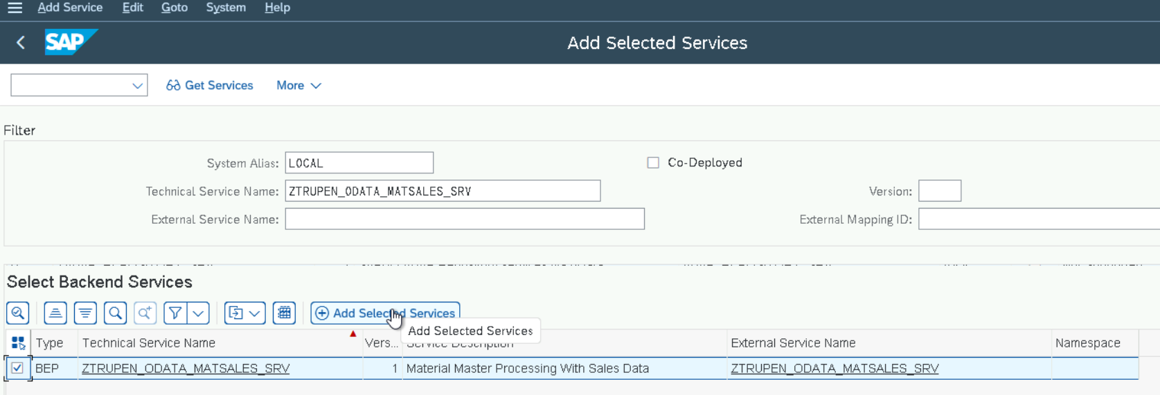

System proposes the Technical Service name and Model name and modify the names if required and choose the Package Name and Click on Enter.

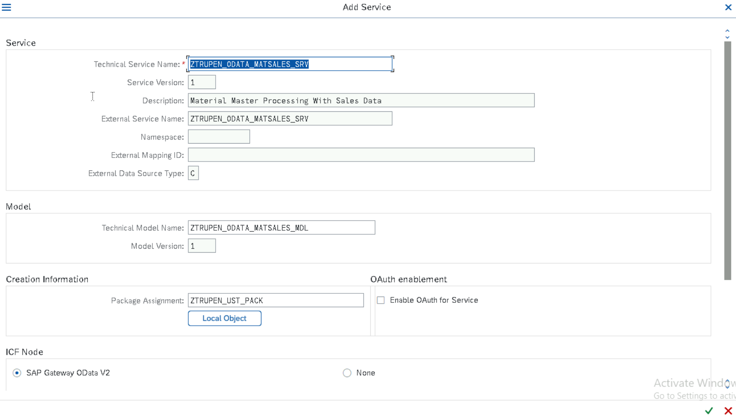

Enter the Transport Number in the below Pop up to save the Metadata and Click on Enter

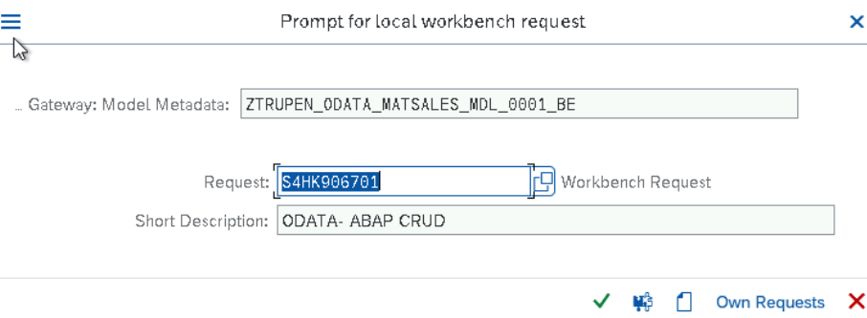

Enter the Transport Number in the below Pop up to save the ICF Service and Click on Enter and go Back

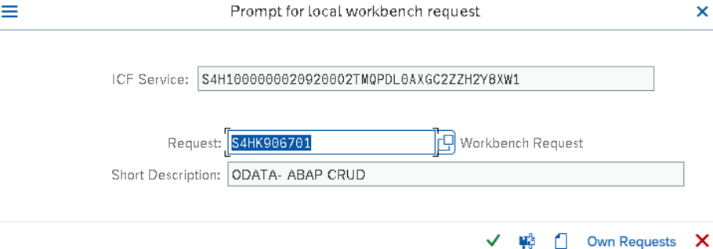

Click on Filter Button and Enter the Technical Service Name and Click on Enter.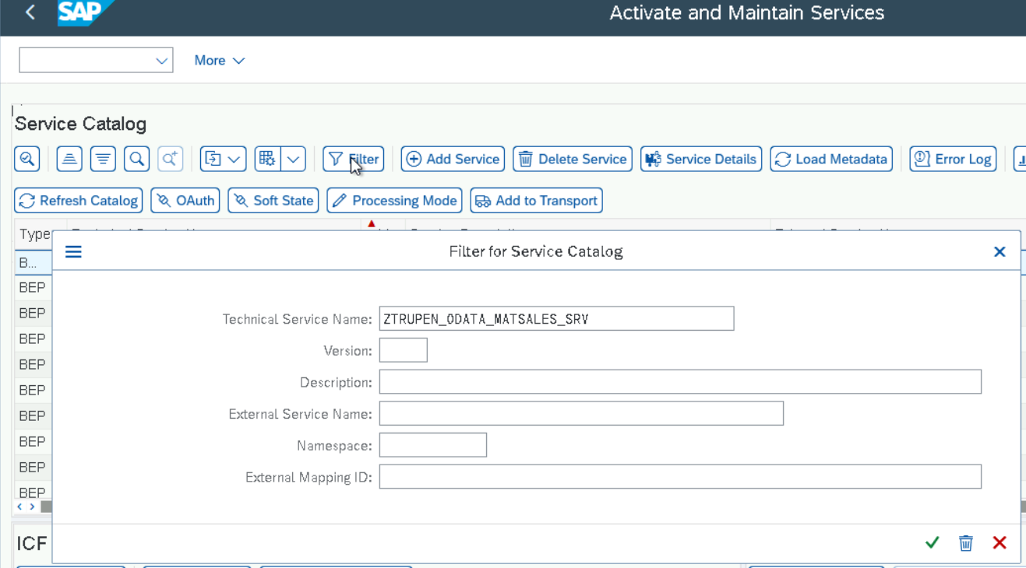

Now the Service can be seen Registered and Click on Configure SICF Button under the ICF Node to add the Parameter to the SICF Services.

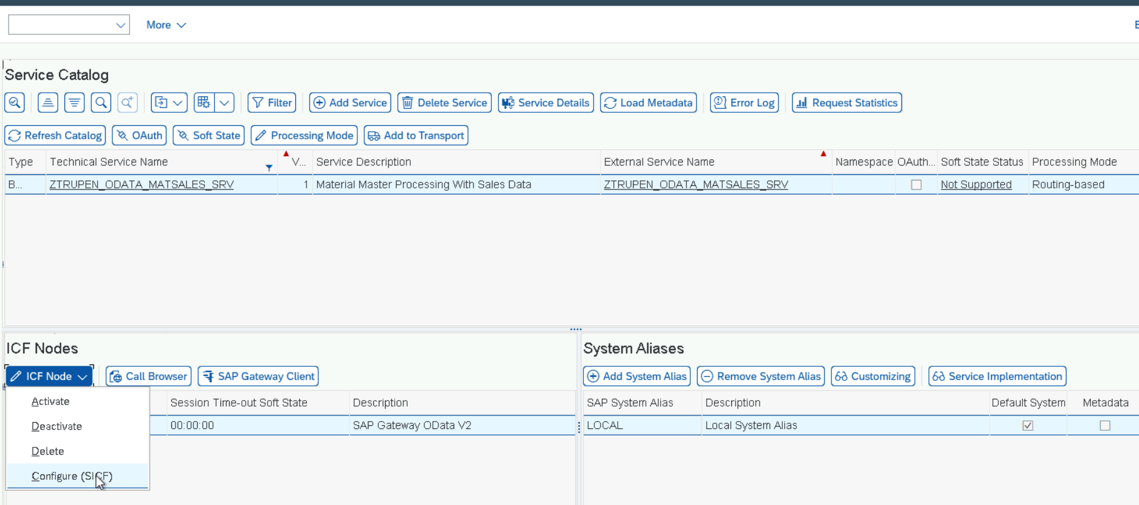

Now the Service will be opened and click on Change mode and Double click on the Service.

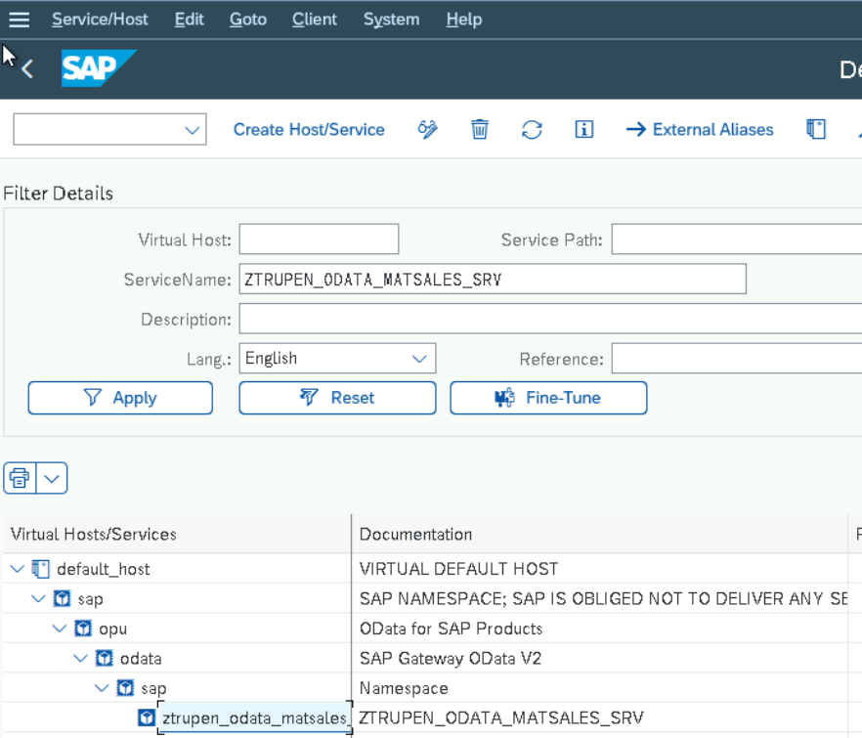

Click on Gui Configuration Button under the Service data Section to add the parameters for Disabling the CSRF token Validation.

Note: This is an optional step and required in this system as the CSRF token setup has to be disabled to test the service from the Gateway client.

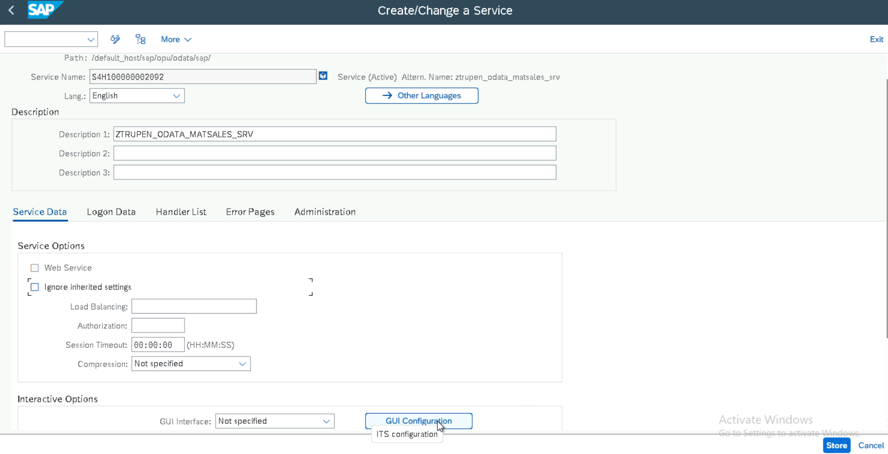

Add the Parameter and Value to disable the CSRF Token and click on Execute Button and save.

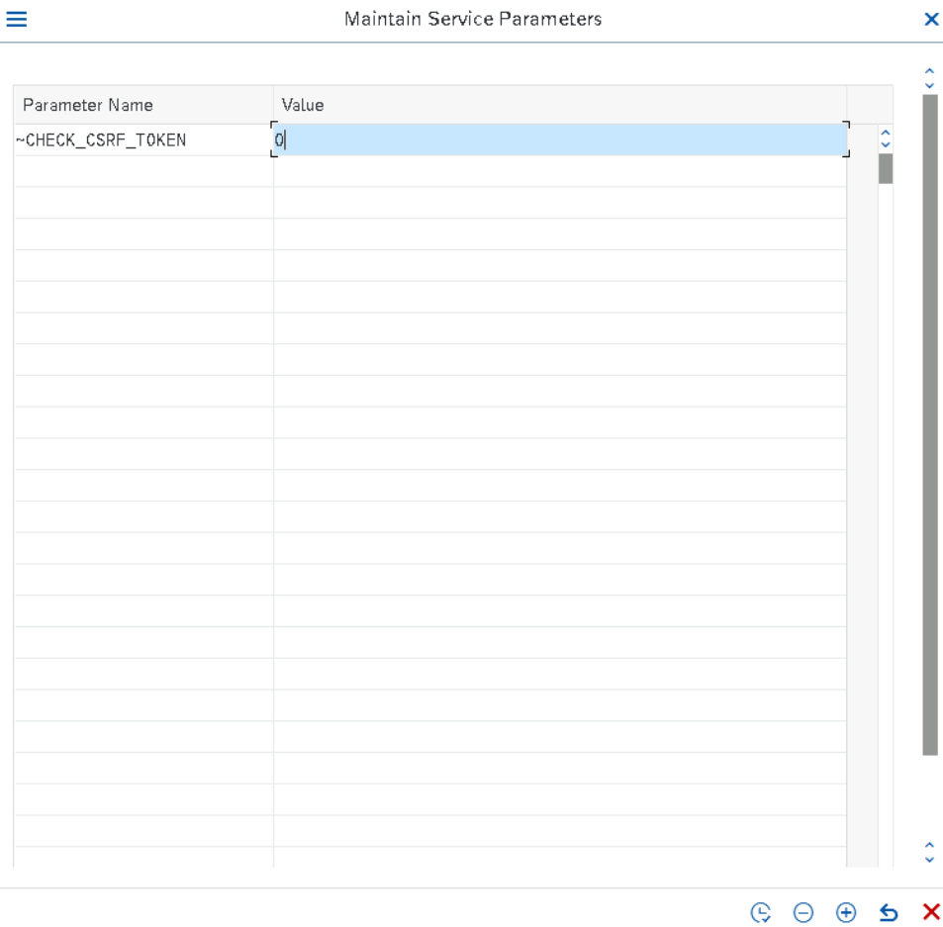

Click on save and go back to the service activation screen and click on Execute SAP Gateway button to test the service.

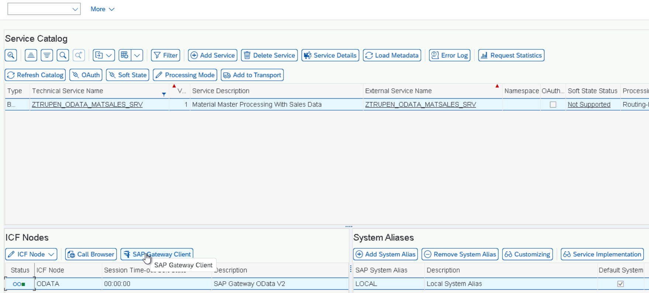

Service is Working fine and the Result shows 200.

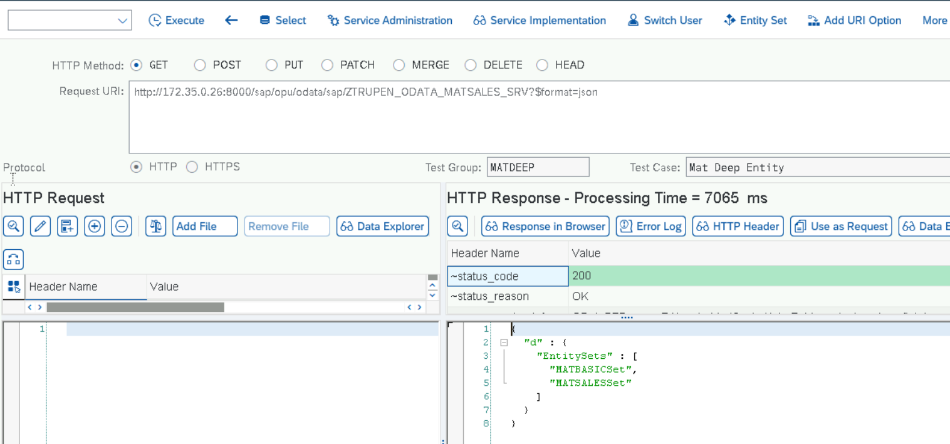

**TESTING:**

Create Deep Entity

URI: http://172.35.0.26:8000/sap/opu/odata/sap/ZTRUPEN_ODATA_MATSALES_SRV/MATBASICSet

HTTP Body structure:

**{**  
**"Maktx":"MATERIAL ODATA Deep Entity",**  
**"Matnr":"MATODATADEEPCRE5",**  
**"Mtart":"FGTR",**  
**"Mbrsh":"1",**  
**"Matkl":"L002",**  
**"Meins":"EA",**  
  
**"MATSALES": [ {**  
**"Matnr":"MATODATADEEPCRE5",**  
**"Vkorg":"1010",**  
**"Vtweg":"10",**  
**"Sktof": true,**  
**"Mtpos":"NORM",**  
**"Dwerk":"1010" } ]**  
  
**}**

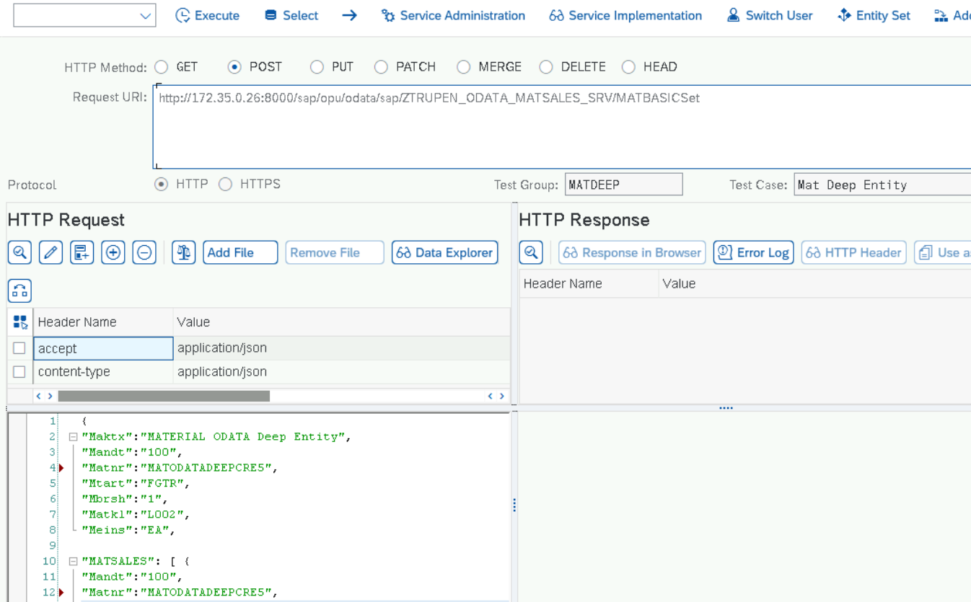

OUTPUT:

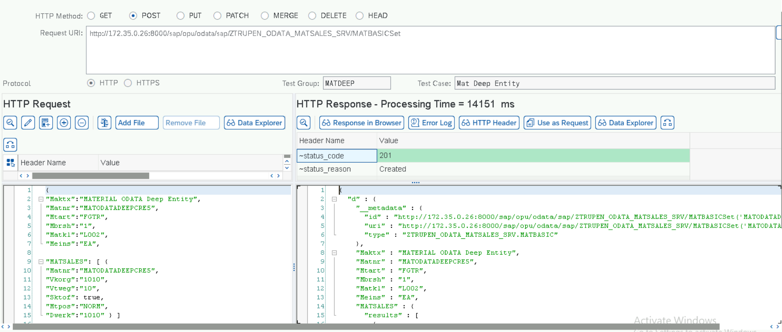

Display Material

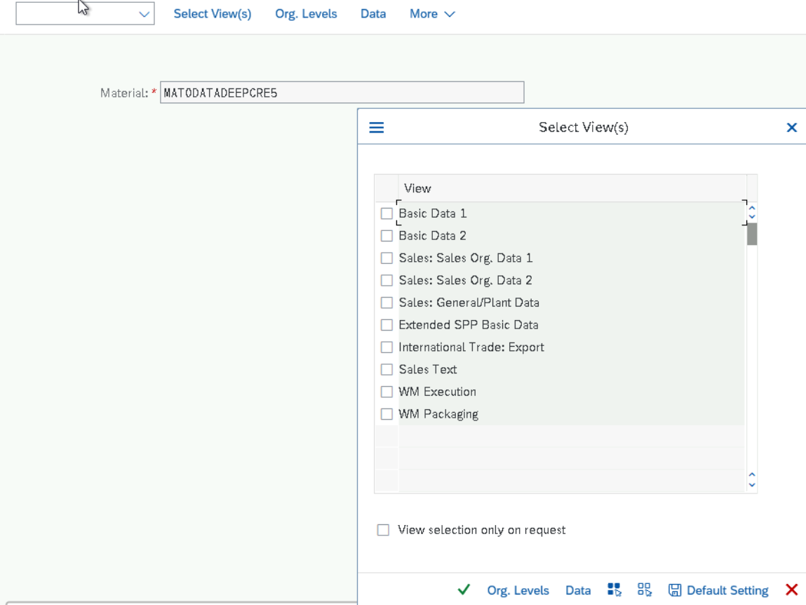

**Get Expanded Entity**

**URI:** http://172.35.0.26:8000/sap/opu/odata/sap/ZTRUPEN_ODATA_MATSALES_SRV/MATBASICSet('MATODATADEEPCRE4')?$expand=MATSALES

**Output**

